

Laboratory Testing of the Improved

SSM FD TLUD Small Stove
Three ISO 19867-1 tests at Aprovecho Research Center on 05/15/26 through 05/19/26. These tests do not constitute an ISO 19867 test series to be used for any official purpose.

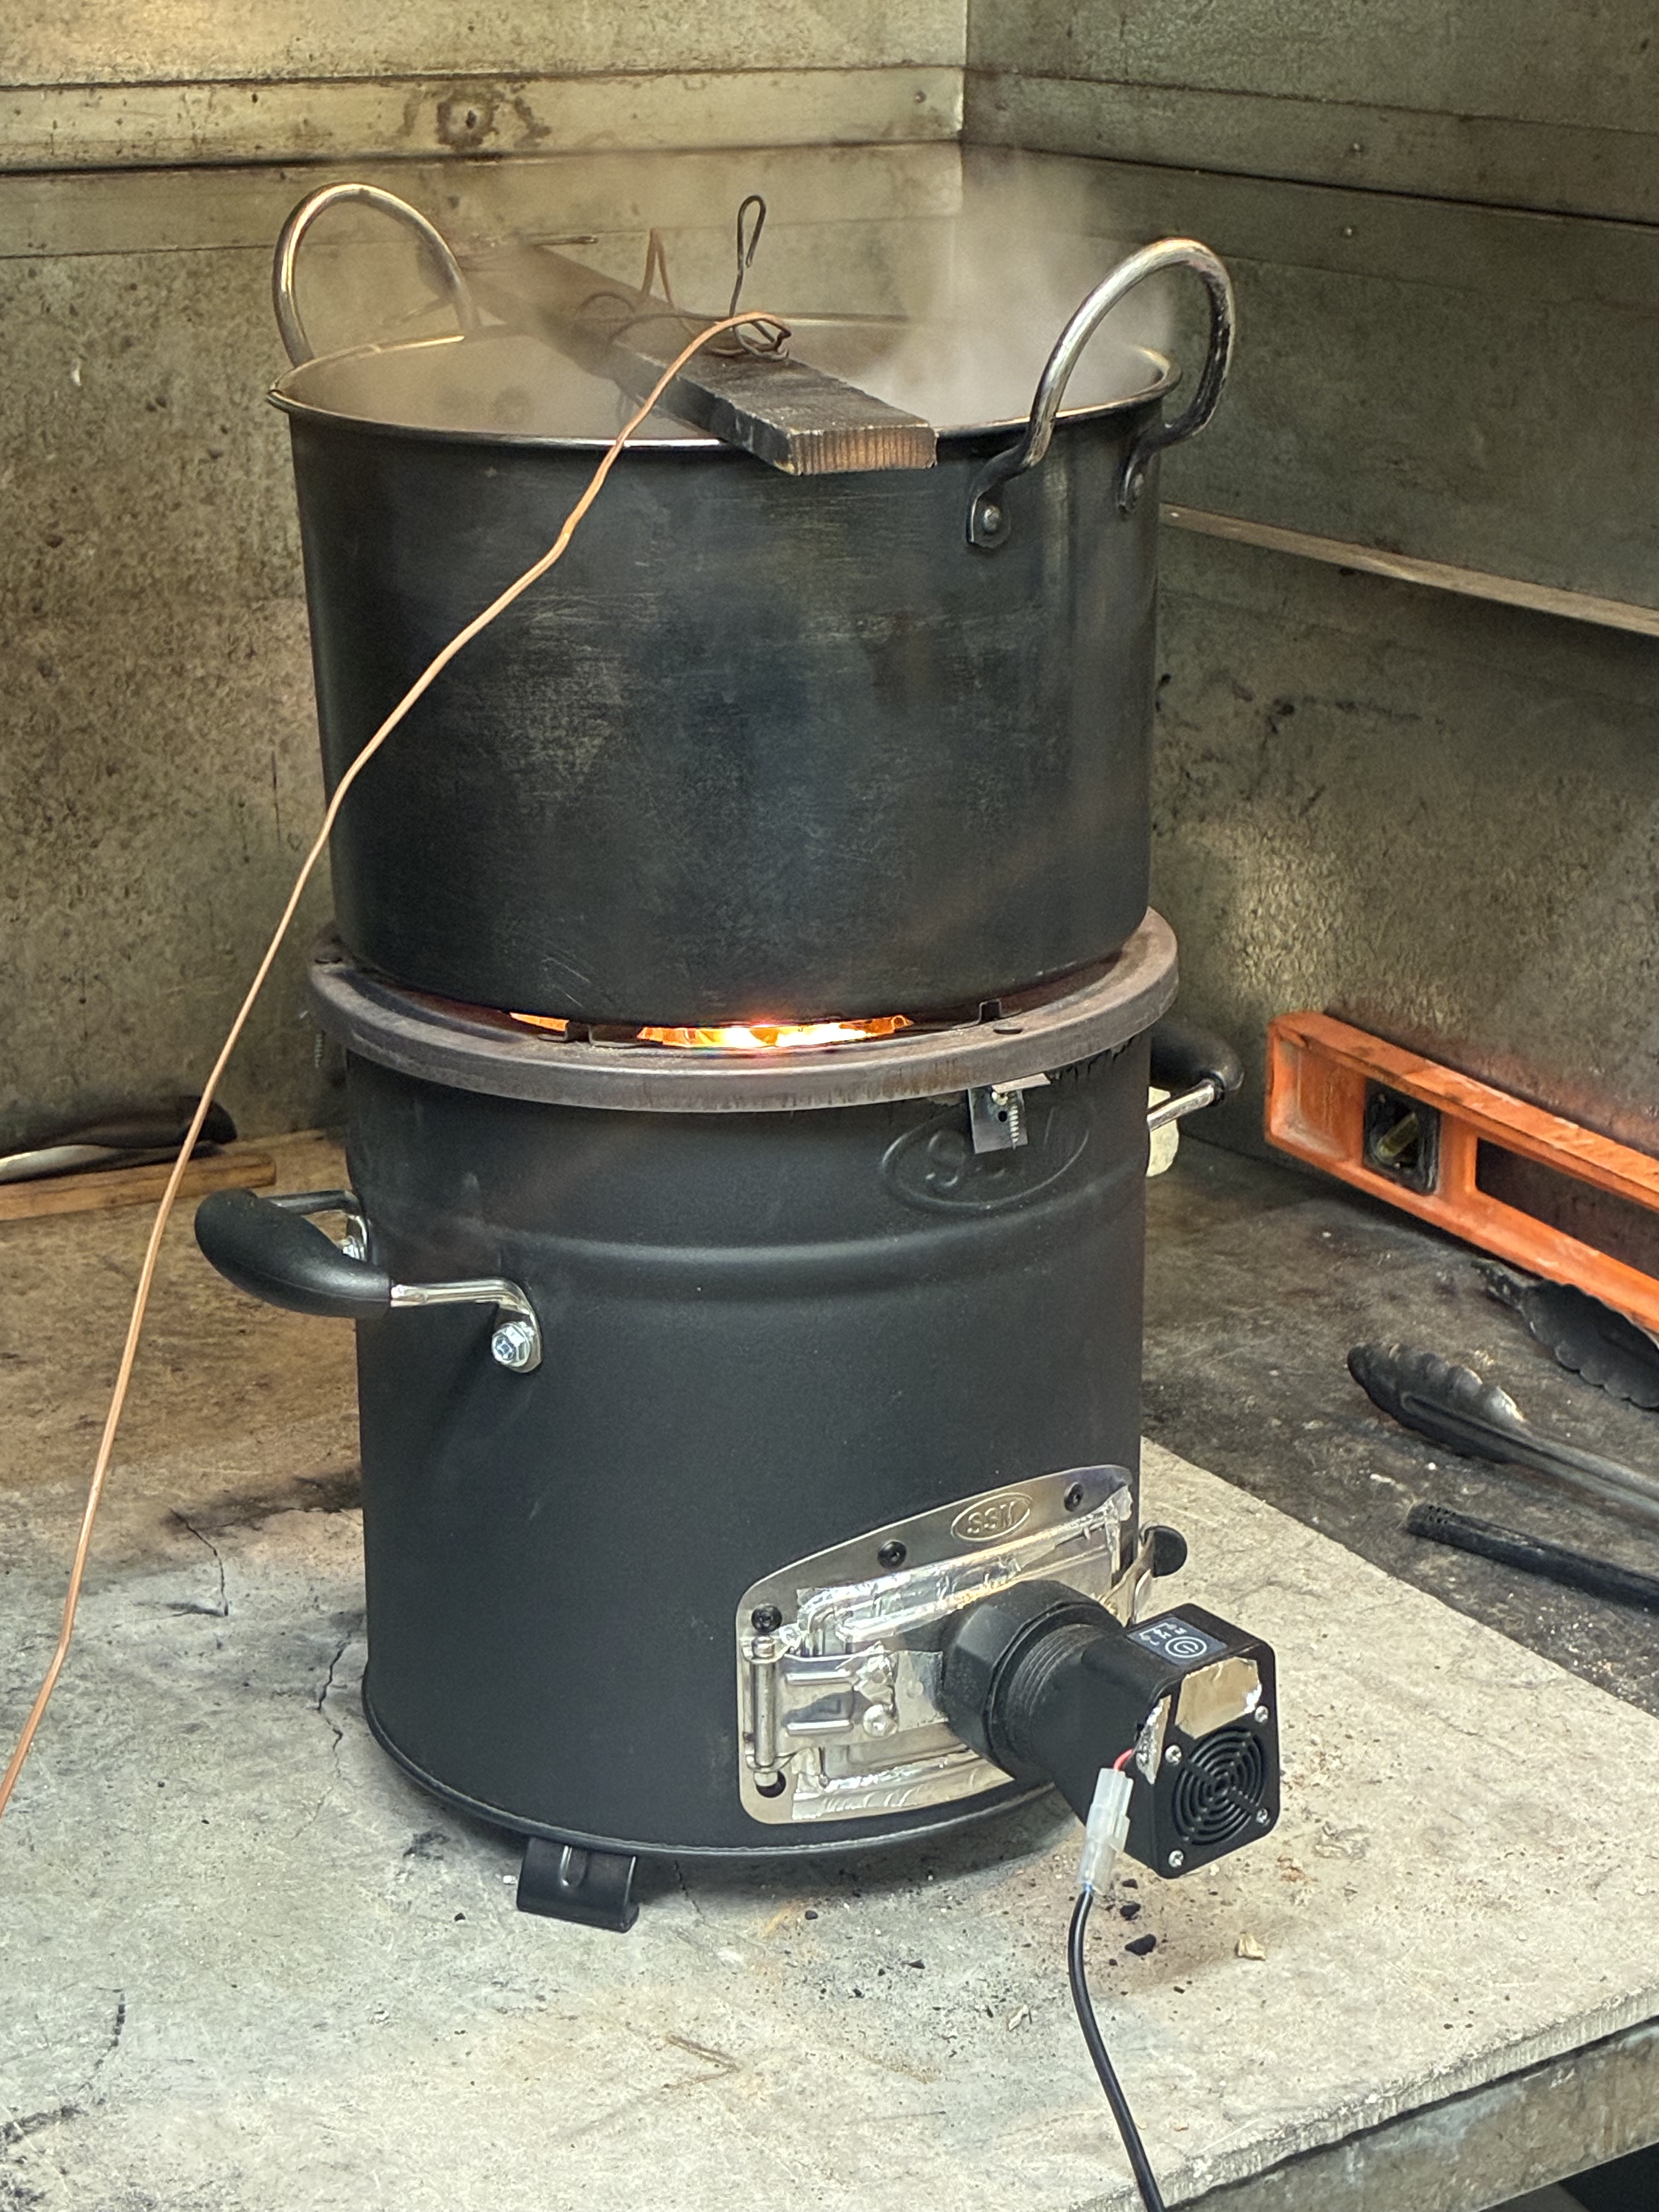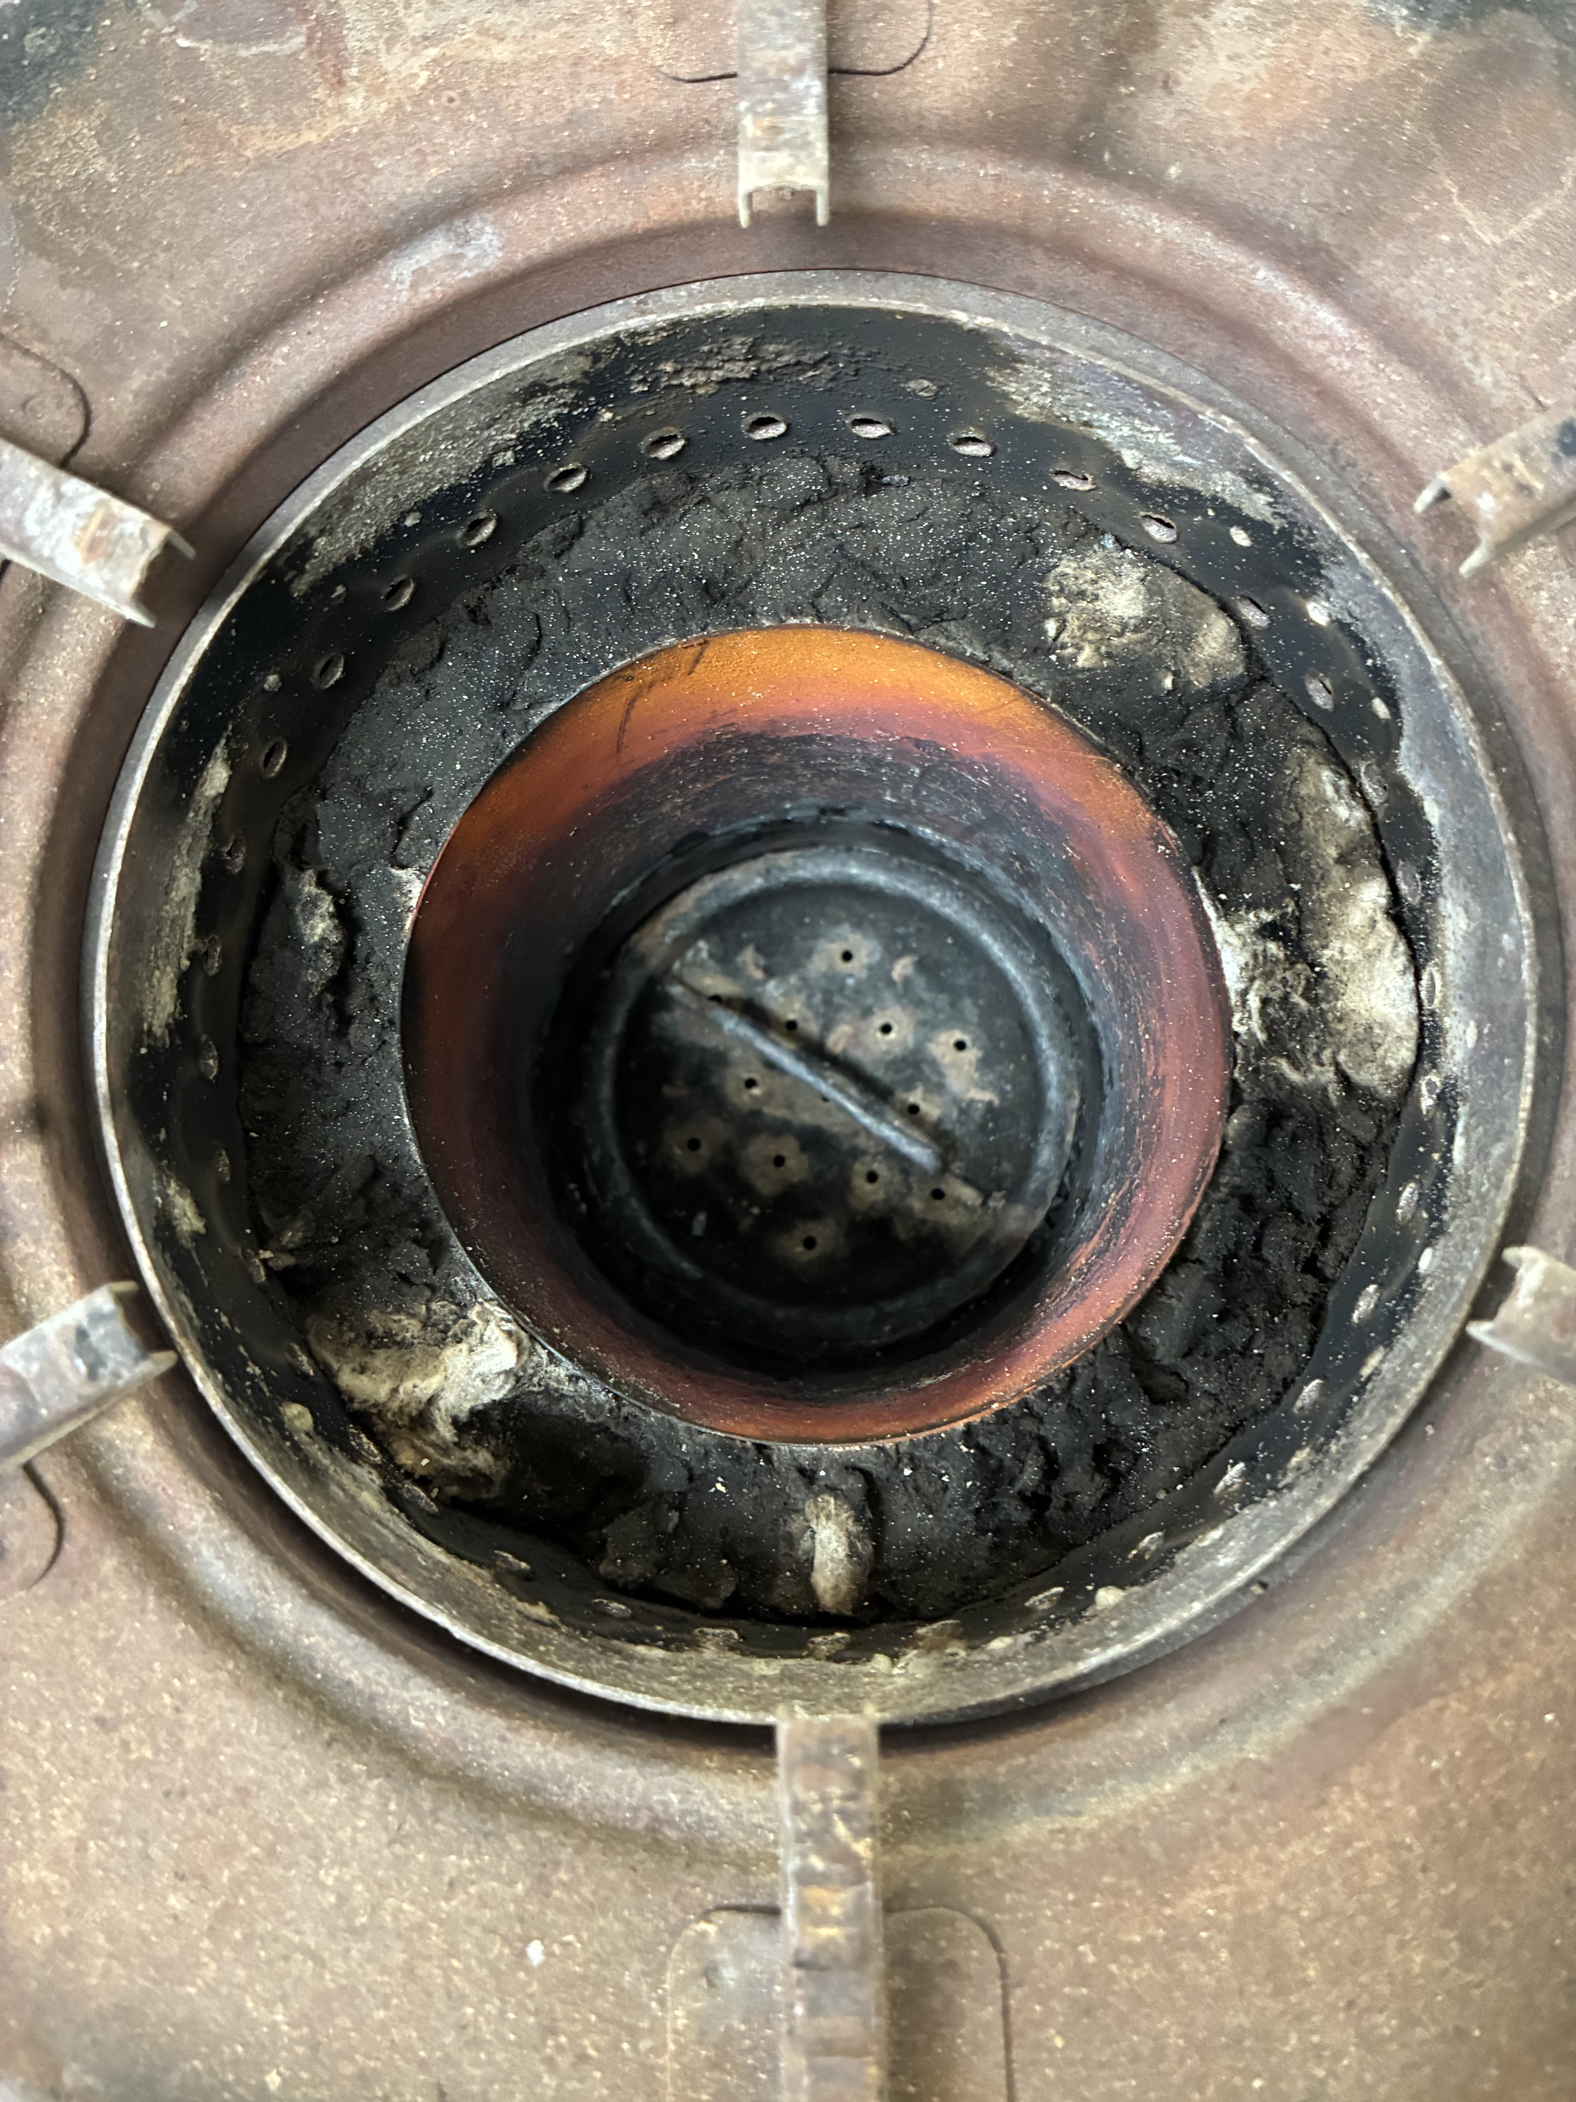

Improved SSM FD TLUD Small prototype
With funding from the Osprey Foundation, the Improved Baldwin Stove was updated at Aprovecho Research Center in April 2026. Three ISO 19867 tests are summarized in this report. A standard laboratory test was carried out using the ARC Laboratory Emissions Monitoring System (LEMS) and the ISO 19867-1:2018 Water Heating Test at three power levels. The primary ISO metrics are provided and are shown with the ISO 19867-3:2018 Voluntary Tiers of Performance. The stove is rated Tier 4 for thermal efficiency without char and Tier 5 with char, Tier 4 for PM_{2.5} emissions, and Tier 5 for CO emissions. Safety and durability tests were not performed.

Chart of results, all tests

variable | units | Tests 1 | Test 2 | Test 3 | Test 4 | Test 5 | average
HIGH POWER
Thermal Efficiency w/o char | %
Thermal Efficiency w char | %
Fire Power | kW
PM2.5 per useful energy | mg/MJ
PM2.5 mass per time | mg/min
CO per useful energy | g/MJ
CO mass per time | g/min
Time to boil | min
MEDIUM POWER
Thermal Efficiency w/o char | %
Thermal Efficiency w char | %
Fire Power | kW
PM2.5 per useful energy | mg/min
PM2.5 mass per time | mg/MJ
CO per useful energy | g/MJ
CO mass per time | g/min
Time to boil | min
LOW POWER
Thermal Efficiency w/o char | %
Thermal Efficiency w char | %
Fire Power | kW
PM2.5 per useful energy | mg/MJ
PM2.5 mass per time | mg/min
CO per useful energy | g/MJ
CO mass per time | g/min
Time to boil | min
TIER RATING
Efficiency without char
Efficiency with char
PM useful energy delivered
CO useful energy delivered

Summary of results

Number of Test Replicates: |  | Test Sequence Phase |  |  |  | Tier Rating
 |  | High | Medium | Low | Average
Thermal Efficiency w/o char | % |  |  |  |  | Tier:
Thermal Efficiency w char | % |  |  |  |  | Tier:
Fire Power | kW |  |  |  |  | n/a
PM2.5 per useful energy | mg/MJ |  |  |  |  | Tier:
PM2.5 mass per time | mg/min |  |  |  |  | n/a
CO per useful energy | g/MJ |  |  |  |  | Tier:
CO mass per time | g/min |  |  |  |  | n/a
Time to boil | min |  |  |  |  | n/a

Description
The upgraded SSM FD TLUD Small Stove is a batch fed stove. The sheet metal stove body is a 26.5 cm tall and 26cm wide with a metal fuel door opening bolted on. The door is sealed shut with tape to prevent air from leaking. The center of the door has an electric variable speed fan that runs at 12v, 6v, and 4v. The stove has a SSM stove top with 6 mm tall spacers as a pot support. There is glass fiber insulation. The original SSM model has a 14 cm wide x 18.5 cm deep combustion chamber with 36 secondary air holes around the top. A separate sheet metal combustion chamber is set inside that combustion chamber, surrounded by glass fiber insulation. It is 10 cm in diameter and 12.5 cm tall, allowing the original secondary air holes to work. The bottom of the combustion chamber has 13 primary air holes that act like a grate to allow for air to circulate up through the fuel.

Methods
The test protocols are described in ISO 19867-1:2018, which is a laboratory test for cookstoves to be evaluated with performance metrics such as thermal efficiency and emissions released per unit energy delivered to the cooking pot. Test results do not predict field performance. Laboratory testing has been shown to significantly underestimate emissions and overestimate thermal efficiency.

Stove and Operating Procedures
To operate the stove at different power levels, more pellets were added for higher firepower and less pellets for lower firepower. For high power, 500g were burned. For medium power, 375g were burned. For low power, 225g were combusted. The high, medium and low powers were batch fed by the operator, predetermining the amount of fuel maintain the power levels. The electric variable speed fan was turned on about one minute after lighting the stove, using 12v for high power, 6v for medium power, and 4v for low power. The combustion process was managed carefully attempting to achieve the various power levels while maintaining high combustion efficiency.

Starting Sequence
To light the fire, 100 grams of pellets, soaked in ethyl alcohol, was placed on the top of the desired fuel load leveled inside the combustion chamber. After ignition the electric variable speed fan was turned on.

Fuel
The stove was operated with pieces of Douglas Fir pellets with dimensions of .5 cm wide x 1 cm tall x .5 cm long with a moisture content of 6 %. The Higher Heating Value of the Douglas Fir was estimated to be 20634 J/g and the Higher Heating Value of the charcoal was estimated to be 32500 J/g.

The Lower Heating Value of both the wood and the charcoal is based on the method specified in the ISO protocol, which depends on the chemical composition of the fuel. The percentage of H, O, and N of the wood was assumed to be 6.3 percentage H, 40.5 percentage O, and 0.1 percentage N, respectively. For charcoal the percentages were assumed to be 3.1 percentage H, 11.3 percentage O, and 0.2 percentage N. The resulting Lower Heating Value of the wood was 19,314 J/g, and for the charcoal, it was 31,300 J/g.

The Effective Heating Value of the wood was estimated to be 16703.16 J/g using the calculation specified in the ISO protocol which is dependent on moisture content.

The Cooking Vessel
A steel seven liter cooking pot was used, which is 25 cm in diameter and 16.5 cm tall.

Voluntary Performance Targets (from ISO/TR 19876-3)
Table 1 – Voluntary performance targets – default valuesª

 | Tier^{b} | Thermal efficiency  (%) | Emissions |  | Safety (score)^{c} | Durability (score)^{d}
 |  |  | CO  (g/MJ_{d}) | PM_{2,5} (mg/MJ_{d})
Better  performance | 5 | ≥50 | ≤3,0 | ≤5 | ≥95 | <10
 | 4 | ≥40 | ≤4,4 | ≤62 | ≥86 | <15
 | 3 | ≥30 | ≤7,2 | ≤218 | ≥77 | <20
 | 2 | ≥20 | ≤11,5 | ≤481 | ≥68 | <25
 | 1 | ≥10 | ≤18,3 | ≤1030 | ≥60 | <35
 | 0 | <10 | >18,3 | >1030 | <60 | >35
ªFor non-default values, see Clause 6.
^{b}The tier level for each performance metric shall be reported separately. See example in Table 2.
^{c}Safety protocols (Clause 7 in ISO 19867-1 [1]) cover solid-fuel stoves and solar cookers only.
^{d} Durability protocols (Clause 8 in ISO 19867-1 [1]) evaluate common material failures in biomass cookstoves. The protocol is not comprehensive of all failures that might be found in the field, nor are the tests found in the durability protocol applicable for all cookstoves. Instead the durability protocol seeks to cover the most prevalent durability concerns found across a range of cookstove technologies and construction materials.

Default Emission Factors (from ISO/TR 19876-3)

The default emission factors for PM_{2,5} (as shown in Table 1 in 5.2) are presented in Table 7 with additional details on the corresponding relative risks, emission concentration, emission rate, and the percentage of homes meeting each tier level.

Table 7 – Default emission factors, rates, equivalent concentrations
and % homes meeting specified criteria, for PM_{2,5}

 | Tier | RR | mg/MJ_{d} | Normalized Emission Rate (mg/min) | µg/m³ | Percentage of homes meeting the tier level
Better  performance | 5 | 1,0 | ≤5 | ≤0,2 | ≤10 | ≥90%
 | 4 | ≤1,5 | ≤62 | ≤2,7 | ≤50 | ≥50%
 | 3 | ≤2,5 | ≤218 | ≤9,5 | ≤170 | ≥50%
 | 2 | ≤3,0 | ≤481 | ≤21 | ≤400 | ≥50%
 | 1 | ≤3,15 | ≤1031 | ≤45 | ≤800 | ≥50%
 | 0 | >3,15 | >1031 | >45 | >800 | <50%
NOTE Tier reporting is based on emission factor, and normalized emission rate is a derived property. Measured emission rates from laboratory testing are not used to determine tiers for reporting.

